Optimizing Grocery Baskets for Health in Kenya: A Hybrid Recommendation System

Tatenda Duncan Kavu^{1,3*}, Agnes Kiragga¹ , Steve Cygu¹, Reinpeter Momanyi¹, Gershim Asiki¹
¹African Population and Health Research Center, Nairobi, Kenya
³University of South Africa(UNISA), South Africa

Targeted Journals:
- Scientific African
- Scientific reports

Abstract
Our recent research has shown that the Kenyan population, particularly males over the age of 50 tends to purchase ultra-processed food items, as defined by the NOVA classification, in supermarkets. The findings also reveal that 53% of grocery supermarket transactions in Kenya involve ultra-processed foods, a trend that could potentially contribute to an increase in non-communicable diseases (NCDs) within the population. In response to this concern, we developed a mobile application powered by an algorithm designed to guide Kenyan consumers in making healthier grocery purchases at brick-and-mortar supermarkets. The algorithm scores individual food items using the NOVA classification system and nutrient composition and suggests healthier alternatives to users. It has been deployed in a mobile application and tested for effectiveness. When evaluated using the UK Food Standards Agency (FSA) traffic light system, the results showed that 33% of the recommended food items fell within the high range, 56% within the medium range, and 11% within the low range. In this system, the medium range includes fat content between 3g/100g and 17.5g/100g, saturated fat between 1.5g/100g and 5g/100g, sugar between 5g/100g and 22.5g/100g, and sodium between 0.3g/100g and 1.5g/100g. Values above these ranges fall into the high category, while values below fall into the low category. Additionally, the recommended items were evaluated using the Kenya Nutrient Profile Model (KNPM), which sets below thresholds per 100g of food at: <7.76g total fat, <6.33g saturated fat, <4.7g total sugar, and <0.26g sodium. Based on this model, 93% of the recommended items were found to be below the threshold values. The algorithm achieved a diversity score of 45.35% and a novelty score of 52.85%. These results were influenced by the limited variety of healthy foods in the dataset, which affected both the diversity and novelty of the recommendations. Overall, the algorithm proved to be effective in recommending healthier food options that can help improve the food choices of the Kenyan population. However, a user survey indicated that the next version of the application should enhance personalization. Notably, 77% of respondents expressed willingness to continue using the app for their grocery shopping, indicating a positive perception of both the algorithm’s performance and the overall application.
Keywords: Nutrition, Kenya Nutrient Profile Model, NOVA, Food Standards Agency, Recommendation, Artificial Intelligence

1 Introduction
According to Samson Gebremedhin and Tilahun Bekele (2021) and the FAOSTAT Food Balance Sheets (1990–2022), Africa's food consumption shows a reliance on carbohydrates, with significant increases in energy supply over recent decades. The data indicate that the per capita dietary energy supply reached 3,132 kcal/person/day by 2017, up from 2,685 kcal/person/day in 1990, reflecting a 16.6% rise. The diet is heavily carbohydrate-based, contributing 73% of total energy, with protein at 8.9% and fat at 17.5%. Specific nutrients, such as saturated fatty acids (5.1%) and polyunsaturated fatty acids (5.3%), highlight the dietary composition, with fruits and vegetables at 356 g/capita/day in 2017.
Based on the same data, East Africa mirrors Africa's trends. The aggregated statistics for nutrient composition are not readily available, suggesting a need for further research. The per capita dietary energy supply for East Africa was 2,625 kcal/person/day in 2017, with carbohydrates at 74.1%, protein at 8.8%, and fat at 16.7%.
According to the FAOSTAT Food Balance Sheets (1990–2022) and the Enhanced Food Balance Sheets Report for Kenya (2014–2018), published by the Kenya National Bureau of Statistics, Kenya's per capita dietary energy supply was approximately 2,300 kcal/day in 2019. Major food items include maize at 190.4 g/day, wheat at 113.1 g/day, potatoes at 81.9 g/day, bovine meat at 38.3 g/day, and milk at 255.6 g/day. Nutrient-wise, carbohydrates contribute around 380 g/day, protein 60 g/day, and fat 60 g/day, reflecting a diet rich in staples and dairy.
The results of the data analysis from the Food Balance Sheets (1990–2027) are summarized in Table 7.
The Ministry of Agriculture, Livestock, Fisheries, and Cooperative of Kenya in 2019 published a healthy food guideline which the people of Kenya might consider to stay healthy. The guide promotes eating less processed grain products indigenous vegetables varieties, fruits rich in vitamin A and C to support immunity and quick healing. Conversely, the guidelines discourage excessive intake of foods high in fats, sugars, and salts, as these can lead to excessive weight gain, diabetes, and high blood pressure, especially when physical activity is limited. Considering these recommendations, individuals should ensure their shopping baskets consistently include the recommended food items while actively minimizing consumption of discouraged foods.
Some recommendation systems have been built in the past to help ordinary people in making the right choice as far as health issues are concerned. These systems suggest a healthy lifestyle to users which include exercises, diet, sleeping time etc. Ayoub El Majjodi et al (2022) conducted an interesting study where they developed a recipe recommender system that integrated digital nudges in the form of nutrition labels to support healthy food choices. Their findings show that Non-personalized recommendations resulted in healthier recipe choices compared to personalized ones. Personalized recommendations tended to be less healthy, as user preferences often favored popular, less healthy recipes. Since their data was quite limited they were not able to examine the effects on a broader range of food-related products.
Klaus L. Fuchs et al (2022) developed a web-based browser extension for online grocery shopping that displayed Nutri-Score labels on food products to guide consumers toward healthier choices. They found that participants exposed to Nutri-Score labels chose products with higher nutritional quality. Participants exposed to the Nutri-Score labels had a slightly positive emotional response and showed marginally higher support for the introduction of such labels. The study was limited to a sample of university students, which may not be representative of the general population. The sample size was also relatively small.

L. Nynke van der Laan & Oliwia Orcholska, 2022 developed a digital Just-In-Time (JIT) nudging system integrated into a mobile self-scanning application used in supermarkets. The system provided visibility nudges and descriptive and evaluative nutritional labeling nudges to encourage healthier food choices at the point of purchase. The visibility nudge increased the percentage of healthier products purchased (37.7%). The visibility nudge alone was effective in promoting healthier choices, while additional descriptive nudges triggered resistance or reactance from consumers. This shows that customers didn’t want to be overloaded with content. The study only assessed immediate behavior changes and did not evaluate long-term effects.

The main problem with the existing Health Recommendation Systems(HRSs) built elsewhere is that the food items recommended differ to some extent in every country, and purchasing patterns also change depending on the context. Despite the fact that, to the best of our knowledge, there is no HRS in Kenya, our findings show that existing HRSs developed to date have not been extensively evaluated on user-centric factors and real-world impact. There is a lack of standard measures to report HRS target users, recommended items, datasets, algorithms, and evaluation protocols. There is also minimal incorporation of contextual information to enhance the relevance and personalization of recommendations. In the context of Kenya, our recent findings suggest that consumers are now more aligned with purchasing ultra-processed food items, especially males above the age of 50 and young males below the age of 25 (momanyi et-al, 2025). Therefore, we have identified a target population that is likely to benefit from the HRS. The evaluation methods in place will be more user-centric since we have carried out a study to understand the association between Kenya’s population demographics and grocery purchasing patterns.
The main aim of this study is to develop an AI-enabled health recommendation system tailored to promote healthy shopping among the Kenyan population, taking into account the diversity of food varieties available in Kenya. This system will leverage advanced algorithms to provide consumers with healthier food choices, thereby contributing to improved public health outcomes.
The primary objective of this study is to create an application that suggests healthy food items ranked according to two distinct criteria: the NOVA classification and the nutrient composition score. The NOVA classification system categorizes food items based on their level of processing: unprocessed/minimally processed, processed culinary ingredients, processed, and ultra-processed. This classification is crucial as numerous studies have demonstrated that higher consumption of ultra-processed foods is associated with an increased risk of chronic diseases such as obesity, diabetes, and cardiovascular diseases (Monteiro et al., 2019).
The nutrient composition score, on the other hand, evaluates food items based on their content of essential nutrients, including protein, fiber, vitamin C, vitamin A, calcium, iron, and total fat. This scoring system ensures that consumers are informed about the nutritional quality of their food choices, encouraging the consumption of nutrient-dense foods which are vital for maintaining good health (Mason & Lang, 2017).
By integrating these two, the recommender application will provide consumers with alternative products to purchase, ranked by their health benefits. This dual-ranking system not only facilitates informed decision-making but also supports dietary diversity and nutritional adequacy, which are essential for preventing nutrient deficiencies and promoting overall well-being (Herforth A et al, 2020). This study will harness scientific knowledge and technological advancements to guide Kenyan consumers towards healthier food choices, ultimately enhancing public health through improved dietary habits.
The major contributions of this work are:
- A hybrid health recommendation system based on NOVA classification and nutrition composition score in Kenya
- An HRS deployed as an android mobile application

Materials and Methods

Data Description and Preprocessing
The natural transactional data from supermarkets normally take the form of Table 1. Table 1 just shows a snippet of how the natural transaction looks like. The data doesn’t show the ingredient composition of the food items. This means in order to identify the nova class of the food item, food class, sub_class, nova class weight some data pre-processing has to be conducted.

Table 1: A snippet of transactional data
Transaction_Id | Branch | Supermarket_Name | Month_Date | Product Description | Price (KSH) | Quantity | Payment Mode
001_003-7 | 001_003 | A | 2020-11-01 | SALIT VEGETABLE OIL 500ML | 91 | 1.0 | Cheque
001_003-9 | 001_003 | A | 2020-11-01 | KINANGOP ESL LONG LIFE MILK 500ML | 45 | 4.0 | Cheque
001_003-9 | 001_003 | A | 2020-11-07 | ILARA YOGHURT FOREST BERRY 150ML CUP | 45 | 4.0 | Cheque
001_003-9 | 001_003 | A | 2020-11-01 | BUTALI BROWN SUGAR 1KG PKT | 105 | 1.0 | Cheque

Preprocessing
Bi-directional LSTM Model
A Bi-directional Long Short-Term Memory (BiLSTM) model was trained to predict a food item’s nova class, class name and sub-class name, nova classes were later on given weights in this format:
{ "Unprocessed/Minimally processed foods": 5, "Processed Culinary Ingredients": 3,
"Processed foods":2, "Ultra-processed foods": 1 }

The BiLSTM network is a type of recurrent neural network (RNN) architecture that processes input data in both forward and backward directions, effectively capturing the context of the food item description from both past and future states in the sequence. This approach enhances the ability of the network to understand the dependencies between different parts of the input sequence of the food item description. This type of neural network has the forget gate, input gate, cell state update and the output gate as highlighted in the following equations.

Forget Gate
$f_{t}=σ(W_{f}.{[h}_{t-1},x_{t}]+b_{f})$ eq(1)
where f_{t} is the forget gate, h_{t−1​} is the previous hidden state, x_{t}​ is the current input, W_{f}​ is the weight matrix, and b_{f} is the bias.

Input Gate
$i_{t}=σ(W_{i}.{[h}_{t-1},x_{t}]+b_{i})$ eq(2)
where i_{t} is the input gate.

Cell State Update
$Ĉ_{t}=tanh(W_{C}.{[h}_{t-1},x_{t}]+b_{C})$ eq(3)
$C_{t}=f_{t}.C_{t-1}+i_{t}.$ $Ĉ_{t}$ eq(4)
where $Ĉ_{t}$ is the candidate cell state, and $C_{t}$ is the updated cell state.
Output Gate
$o_{t}=σ(W_{o}.{[h}_{t-1},x_{t}]+b_{o})$ eq(5)
$h_{t}=o_{t}.tanh(C_{t})$ eq(6)
where $o_{t}$ is the output gate, h_{t ​} is the hidden state.

The resulting mapping of the preprocessed data is as shown below shown in Table 2.

Table 2: Food items classifications
Item Description | NOVA Class | Class Name | Sub-Class Name | NOVA Class Weight
CADBURY DREAM BAR 80G | Ultra-processed foods | CHOCOLATE | CHOCOLATE BAR | 1
PIKA VEGE OIL 5L | Processed Culinary Ingredients | COOKING OIL | VEGETABLE OIL | 3
DELICIOUS DELIGHT MUFFINS CHOC/CUP 300G 6 PKT | Ultra-processed foods | CUPCAKES/MUFFINS/QUEENCAKES | MUFFINS | 1
SWEET HEART CAKE 400G M/B | Ultra-processed foods | MARBLE CAKES | MARBLE CAKES | 1

Kenyan Food Nutrient Composition

Kenya’s Ministry of Health (MOH) in 2017 working with the Nutrition and Dietetics Unit and the Ministry of Agriculture and Irrigation (MOAI) developed a list of food items popularly known in Kenya. The list of the food items also includes the nutrient composition of each food item. Table 3 shows a snippet of some of the food items in that list. We created an algorithm that would rank food items from the list and generate a ranking score, based on the most important nutrients in each food item.

Food Item Score Algorithm

Using the 2019 Kenya’s Ministry of Agriculture, Livestock, Fisheries, and Cooperative healthy food guideline and the Kenya Nutrient Profile Model we found out that there are important nutrients in food items to be encouraged and other nutrients which should be discouraged as highlighted in the introduction. Therefore from these findings we saw that nutrients such as plant proteins, fiber, vitamin C, vitamin A, Calcium and Iron are regarded as important in healthy foods. However, animal fat or food items with a high fat concentration are discouraged. Therefore we developed a scoring algorithm that scores food items by giving percentage distribution to nutrient compositions as follows:

- Protein (25%)
- Fiber (20%)
- Vitamin C (15%)
- Vitamin A (15%)
- Calcium (10%)
- Iron (10%)
- Total Fat (-5%, negative weight to prefer lower fat content)

This was a technique used to score food items by the existence of these nutrients in food items with these percentages. As shown in the algorithm below the food items in Table 3 were therefore scored and given scores as shown in Table 4.

weights = { Protein (g): 0.25, Fiber (g): 0.20, Vitamin C (mg): 0.15, Vitamin A (µg): 0.15,
Calcium (mg): 0.10, Iron (mg): 0.10, Total fat (g): -0.05 }

Definitions

Let N be the set of nutritional components considered, such that:
- N={Protein, Fiber, Vitamin C, Vitamin A, Calcium, Iron, Total fat}
Let w_{i}​ be the weight assigned to the i-th nutritional component, where:
- w={w_{1​},w₂​,…,w₇​} = {0.25, 0.20, 0.15, 0.15, 0.10, 0.10, −0.05}
Let C be the quantity of the i-th nutritional component in the food item (obtained from Table 3), such that:
- N = {n₁​, n_{2​},…, n₇​}

Mathematical Expression

The score S for the food item is calculated as a weighted sum of its nutritional components:
$S= \sum_{i=1}^{7}{}$ w_{i}​ x n_{i}​
Where:
- w_{i}​ is the weight associated with the i-th nutritional component.
- n_{i}​ is the quantity of the i-th nutritional component in the food item.

Breakdown of Calculation:
- Protein Score Contribution: w₁×n₁=0.25×Protein (g)
- Fiber Score Contribution: w₂×n₂=0.20×Fiber (g)
- Vitamin C Score Contribution: w₃×n₃=0.15×Vitamin C (mg)
- Vitamin A Score Contribution: w₄×n₄=0.15×Vitamin A (µg)
- Calcium Score Contribution: w₅×n₅=0.10×Calcium (mg)
- Iron Score Contribution: w₆×n₆=0.10×Iron (mg)
- Total Fat Score Contribution: w₇×n₇=−0.05×Total fat (g)
Table 3: Kenya’s food list and nutrient composition
Food name | Energy (kJ) | Energy (kcal) | Water (g) | Protein (g) | Fat (g) | Carbohydrate available (g) | Fiber (g) | Ash (g) | Ca (mg) | Fe (mg) | Mg (mg) | P (mg) | K (mg) | Na (mg) | Zn (mg) | Se (mcg)
Black (African) nightshade, indigenous, leaves, picked, raw | 127 | 31 | 88,6 | 3,8 | 0.1 | 1,3 | 4,3 | 1,8 | 100 | 8,6 | 41 | 68 | 421 | 10 | 0,65 | 1
Broccoli, tops and stems, boiled, drained (without salt) | 129 | 31 | 90,1 | 3 | 0,3 | 2,4 | 3,3 | 0,9 | 56 | 0,6 | 11 | 61 | 151 | 15 | 0,41 | 0
Ice cream, vanilla flavor, regular fat | 834 | 199 | 62,7 | 3,9 | 10,6 | 22,2 | 0 | 0,7 | 117 | 0,2 | 12 | 84 | 142 | 64 | 0,23 | 1
Beef, lean, raw | 439 | 104 | 75,6 | 20,6 | 2,3 | 0,4 | 0 | 1,2 | 5 | 2,3 | 24 | 279 | 241 | 107 | 4,22 | 15
Cassava and Red Sorghum Ugali | 489 | 116 | 69,6 | 2,1 | 0,8 | 23,4 | 3,4 | 0,7 | 24 | 0,9 | 38 | 74 | 163 | 9 | 0,5 | 5

Table 4: Kenya’s food list and nutrient composition scores
Food name | Protein (g) | Fiber (g) | Vitamin C (mg) | Vitamin A (Âµg) | Calcium (mg) | Iron (mg) | Total fat (g) | Score
Lamb, liver, boiled (without salt) | 30.8 | 0 | 21 | 38100 | 12 | 12 | 7.8 | 5727.86
Fish liver oil | 0 | 0 | 0 | 30000 | 0 | 0 | 100 | 4495
Beans, lima, dry, raw | 22.4 | 18.2 | 64 |  | 1447 | 2.6 | 39.7 | 162.715
Milk, cow, powder, whole | 26.1 | 0 | 3 | 395 | 975 | 0.5 | 26.4 | 162.455
Kale (sukuma wiki), boiled, drained (without salt) | 2.9 | 4.4 | 51 | 152 | 364 | 2 | 0.3 | 68.64

The Recommendation Algorithm
The first data to be collected from the user to start generating recommendations is the user budget and the first item added in the basket. As soon as a user sets the budget, the first item in the basket and an optional list of preferred items, the algorithm will start generating recommendations.

Step 1

The first step of the algorithm is to filter all items in Table 4 that are found in the basket. This is done in order to find the nutrient score of the items in the basket. The filtering process takes the procedure shown below:

Nutrient Scores of items in the basket

Definitions
- Let D={d₁,d₂,…,d_{n}} be the set of descriptions in the basket, where each d_{i}​ represents a description of a food item in the basket.
- Let R={r₁,r₂,…,r_{m}} be the set of food names in Table 4, where each r_{j}​ represents a food name in Table 4.
- Let S={s₁,s₂,…,s_{m}} be the set of corresponding scores for each food name s_{j}​ in Table 4.
- A function Similarity(d_{i},r_{j}) that computes the similarity score between item description d_{i​} and scored food name r_{j}​.
- Let T be the threshold value for similarity matching

Assign Score:
If the threshold condition T is met, assign the score s*_{j}​ from the scored data in Table 4 corresponding to r*_{j}​​ to the description d_{i}​:

Score(d_{i}​)=s*_{j}

If the threshold condition is not met, assign a None score:

Score(d_{i}​)=None

Put all the food items which matched with the food items in the basket in a data structure. Where each food item contains the original description along with the assigned score Score(d_{i}​).

Step 2

The second step of the algorithm is to find similarities between items in Table 4 and items in the preferred list. If some items in the preferred list are found in Table four, the item name(s) and the corresponding nutritional score are picked. These items are merged with the items which are already in the basket to avoid duplicates.

Definitions
- Let D={d₁,d₂,…,d_{n}} be the set containing food items with attributes: category_class name, sub_category_class name, nova weight, price, nova class, and nutrient score.
- Let B={b₁,b₂,…,b_{m}} be the set of food names in the current basket, where each b_{j}​ represents a food item already selected
- Let P = {p₁,p₂,…,p_{m}} be the set of preferred items provided by the user.
- A function Similarity(d_{i},r_{j}) that computes the similarity score between item description d_{i​} and scored food name r_{j}​.
- Let T be the threshold value for similarity matching

Filter Items Based on User Preferences:

- If preferred items P are provided, find similar items in Table 4 and combine them with B
B_{filtered} = $\{$B ∪ find_similar_items(Tabe 4, P) if |P| >0

- Remove duplicates based on items descriptions
B = drop_duplicates(B_{filtered}​, by=’description’)

Step 3

The third step and most important, is the application of linear programming. Linear programming makes sure that the items which remain or get added to the basket have the highest scores and the highest NOVA class weight.

Definitions
- Let the budget be the total budget available.
- Let nova_weights(n) be a function that returns the weight associated with a nova class n.
- Let Score(i​) represent the score of item i​=d_{i} in D.

Calculate Remaining Budget:
- Let current_total_price be the total price of items in B:
Current_total_price = $\sum_{iϵ B}{}price_new(i)$
Remaining_budget = budget − current_total_price
The Optimization Problem:
- The objective function c as the negative sum of nova weights and scores:
c_{i}​=−(nova_weights(nova(i))+score(i))
c= {c_{i}​∣i ∈ B​}
- The inequality constraints for the budget:
A_{ub} = { $\sum_{iϵB}{}price_new(i)$ }
b_{ub}​ = {remaining_budget}
- The bounds for each item i in B:
bounds_{i ​}= (0,1)∀ i ∈ B​​

Linear Programming Optimization:
result=linprog(c, A_{ub}​, b_{ub​}, bounds, method=’highs’)
Select and Rank Items:
- If the optimization is successful, select the items where the decision variable is greater than 0.5:
selected_items={i ∈ D∣result.xi​ > 0.5}
- Rank selected items first by weight and then by score, and return the top 5 items:
Selected_items = sort_and_select_top(selected_items,by=[’weight’, ’score’],top_n=5)

Step 4

Suggesting healthy food items to customers is quite intriguing due to the fact that there is an awareness of purchasing food items that fit their budget, that is what step 3 does in the algorithm. However it is also quite logical to recommend other healthier options within the categories of the items in the basket which are out of the budget of the customer. This is the intuition behind step 4 of the recommendation algorithm. In this step, the algorithm goes through the food items in the optimized basket and looks for other food items with higher nova weights but in the same category with the food items in the optimized basket. The list of items recommended at stage 4 are treated as a last option to the customer.

Definitions:
- Let N be the number of top items to return.
- Let class(i) represent the class of an item i.
- Let weight(i) represent the NOVA weight of an item i.
- Let desc(i) represent the description of an item i.
- Let nova(i) represent the NOVA classification of an item iii.
R =∅
Where R is the set of items with higher NOVA weights to be identified

For each item i ∈ B, do the following:
Predict the subclass of item i:
sub_category_class_pred(i) = BiLSTM(desc(i))
nova_weight_pred(i) = BiLSTM(desc(i))
Find items of the same subclass with a higher weight:
Let H_{i}​ be the subset of items in D that have the same sub_category class name as the predicted sub_category_class of i and have a NOVA weight greater than or equal to the predicted nova_weight i:
H_{i}​ = { j ∈ D ∣ sub_category_class(i)=sub_category_class_pred(j) & nova_weight(j) ≥ nova_weight_pred(i) }
R = R∪ H_{i​}
Let T=TopN​ (Sort (R, by weight, descending))

Where T is the set of top N items by NOVA weight, sorted in descending order, ensuring that items with duplicate descriptions are not included.

The result of these four steps are the items that are presented to the customer as healthier options during purchasing.

Experiments
The algorithm was tested on the Nutriguide Kenya/Lishebora mobile application (https://nutriguide.aphrc.org/static/lishebora_update.apk). The microservice architecture of the application is shown in Figure 1. The architecture was designed with the capability of integrating with IoT devices, Large Language Models, and Large Vision Models for more advanced and sophisticated inferences in the future. For now, the algorithm functions as an agent within the recommendation engine of the architecture. The app is also integrated with an LLM (Llama 3.2) to provide explanations for the recommended food items. Product data will primarily come from the databases of the supermarket(s) and will be accessed via an API for security reasons.

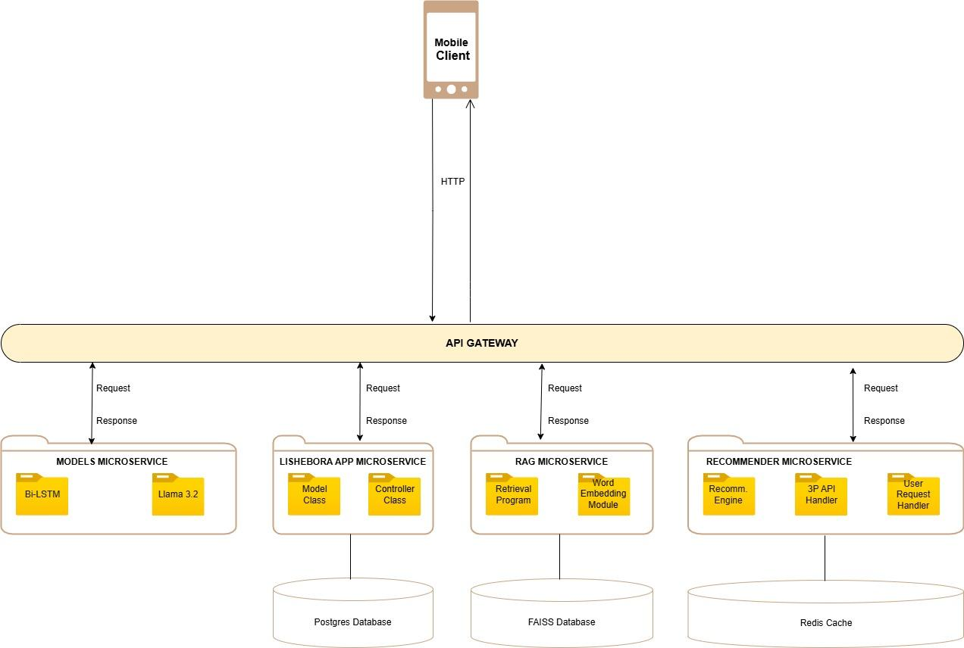
Figure 1: Microservice Architecture for the Application

Evaluation Methods

User’s Perceived List Attractiveness (PLA)
Users were presented with eight propositions and were asked to indicate on a 5-point Likert scale to what extent they agreed with each proposition. These items were designed to capture a user’s perceived attractiveness of a list of recommended food items. Figure 2 shows the Likert scale as displayed on the mobile application.

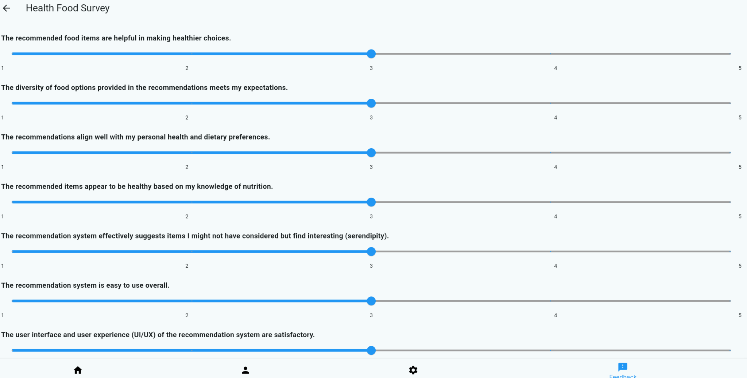
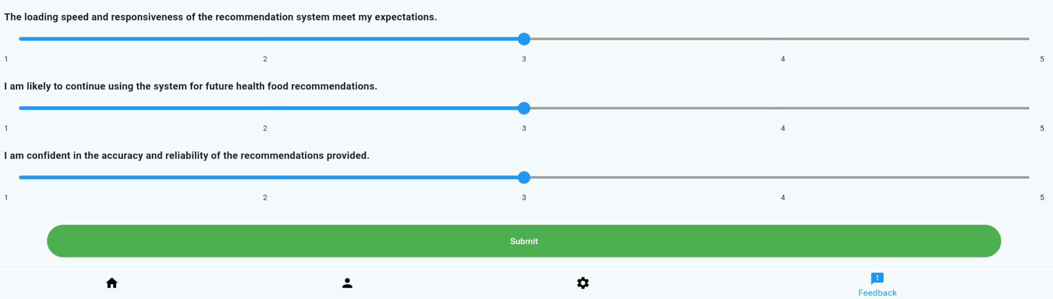
Figure 2: A screenshot of the likert scale of the mobile application

UK Food Standards Agency Score
The UK Food Standards Agency computes foods’ healthiness also known as the ‘FSA score’. (Alain D. Starke et al, 2021). Figure 2 depicts how it is computed, scaling three macronutrients: sugar, fat, and saturated fat. Salt from green (healthy) to red (unhealthy). In this work we computed the healthiness of the food items recommended to clients based on the average healthiness of the items in Figure 2 and Table 3 i.e. we look up in Table 3 the nutrient composition of the items in the basket and compute in grams the average values of fat, sugars and salt. The results of the computation were then compared with the FSA traffic light system to find out where the averages lie in Figure 2. That determines the healthiness of items recommended to clients.

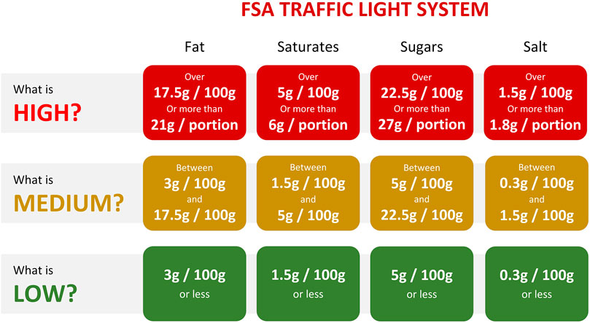
Figure 2: FSA Traffic Light System for Scoring food items healthiness (Alain D. Starke et al, 2021)

Kenya Nutrient Profile Model
The Kenya Nutrient Profile Model provides a method for differentiating foods based on nutrients of concern, such as sodium, sugar, fats, and saturated fats, similar to the UK FSA traffic light system(Kenya Nutrient Profile Model, 2024). The model recommends that all processed foods should not contain more than 2g of industrially produced trans fats (iTFAs) per 100g of total fat. For sodium, the threshold is determined using a ratio of 1mg of sodium per 1kcal of declared energy on a product, which is then converted into grams.
The average nutrient thresholds for the eight categories of food items outlined by the KNP Model are as follows (per 100g or 100ml for pre-packaged foods):
- Total fat (g): 7.76
- Saturated fat (g): 6.33
- Total sugar (g): 4.77
- Sodium (g): 0.26
Using the Kenya Nutrient Profile Model(KNPM) we aim to classify food items as either above threshold or below threshold based on nutrient composition relative to their weights, compared against thresholds.
Given:
- N be the number of food items in the recommended set.
- Nutrient matrix C
- Weights vector W
- Threshold vector T, represents the nutrient thresholds (per 100g or 100ml).
- W_{i}​ be the weight of a food item i.
- C_{ij​} be the nutrient content of the j-th nutrient for the i-th food item.
- Normalize(C_{ij},W_{i}) scales nutrient j to a per 100g/ml basis:
Normalize(C_{ij},W_{i}) = (${\frac{{Cj}_{}^{}}{Wi}}_{}^{})$X 100
The KNPM classification for item i is:
Classify(i) = { ‘exceeds threshold’, ∃j: （(${\frac{{Cj}_{}^{}}{Wi}}_{}^{})$X 100）> T_{j​}
‘below threshold’, Otherwise
And the results for all items are:
Result = [Classify(i) ∀i ∈ Recommended Items]
​

Diversity

Diversity refers to the uniqueness of the recommended items in a recommendation system. Diversity is measured by the proportion of unique recommendations made to users who have never been recommended before (kavu et al, 2019).

$$\frac{unique recommendations }{number of recommendations} *100$$

Novelty

Novelty assesses how unfamiliar the recommended items are to the user (kavu et al, 2019). It is defined as the ratio of unknown items to the total items in the recommended list that the user might like. The novelty per user is calculated as the proportion of items in the recommendation list that are unknown to them. The average novelty of the algorithm is determined by aggregating these individual novelties across all active users who received recommendations.

Given $L ⊆ I_{R}$, where $I_{R}$ is the recommended list, L is the set of items in $I_{R}$ that the user(u) likes, L can be partitioned as$L = L_{k} ∪ L_{u}$ into those items, $L_{k}$ is already known items to the user, and Lu is unknown items to the user. Then the novelty per user is:
$$Novelty(R) = \frac{\left|L_{u}\right|}{L}$$

where R is the set of all active users who received recommendations.

Results
Using the FSA score metric, we conducted several experiments simulating customers purchasing food items in a supermarket. We ran 100 offline experiments, during which 100 baskets were randomly created from the large dataset of food items. Each basket initially contained only one item, along with a list of zero or more preferred items by a simulated customer. Each basket was also associated with the customer's budget, which was randomly generated within a range of 100 to 1000 shillings. Similarly from the same 100 recommendations generated by the algorithm when implementing the FSA scoring, we selected the top 5 recommended items, retrieved their nutrient composition, and then re-examined the nutrient composition of each food item, focusing on the KNPM thresholds of fat, saturated fat, sugar and sodium. Table 5 shows the first four recommendations, the FSA scoring and the KNPM ranking of the food items in each recommendation.
Table 5: Recommended Items, the FSA Ranking and the KNPM thresholds

Exp No | Recommended Items | Budget (KSH) | FSA Rank | KNPM Ranking
1 | FESTIVE SUPREME WHOLEMEAL BREAD 400G, FESTIVE SUPREME WHOLEMEAL BREAD 800G, TAMU WHITE BREAD 400G, BROADWAYS WHITE BREAD 400G, FESTIVE MILKY WHITE BREAD 400G | 882 | Medium,  Medium,  Medium,  Medium,  Medium | Below threshold,  Below threshold,  Below threshold,  Below threshold,  Below threshold
2 | DOUGHNUT PLAIN 80G, CHIGS TOMATO CRISPS 50G, ROCK BAN 200G, FRUITVILLE TROPICAL RTD 500ML, FAMILA UJI MIX 500G | 195 | High,  Low,  Medium,  Medium,  Medium | Exceeds threshold,  Below threshold, Unknown,  Below threshold,  Below threshold
3 | FESTIVE SUPREME WHOLEMEAL BREAD 400G, FESTIVE SUPREME WHOLEMEAL BREAD 800G, TIC TAC ORANGE 16GM, BROADWAYS BROWN BREAD 400G, BROADWAY WHITE BREAD 200G | 727 | Medium,  Medium,  Low,  Medium,  Medium | Below threshold,  Below threshold,  Below threshold,  Below threshold,  Below threshold
4 | CHIGS SALTED CRISPS 100G PLN, AQUAMIST FLAV WATER MANGO 500ML, H.O.MANJI DUOS BISCUIT 60G, ORCHID VALLEY DELIGHT 1L APPLE, H.O.MANJI ORANGE WAFER 15G | 157 | Medium,  Low,  High,  Medium,  Low | Below threshold,  Below threshold,  Below threshold,  Below threshold,  Below threshold

From the 100 recommendations generated by the algorithm, the FSA ranks were: High=149, Medium=253, Low=48 and the KNPM ranks were: Exceed Threshold=31, Below Threshold = 419.

Diversity
From the 100 recommendations generated by the algorithm, we calculated the number of unique recommended items as a percentage of the total recommended items and determined the average diversity across all 100 recommendations. The diversity score was 45.35%.

Novelty
Novelty was computed based on the unfamiliarity of the recommended items. For 100 simulated recommendations, we calculated the percentage of items unfamiliar to the customer, based on their preferred list, and determined the average novelty across all 100 recommendations. The novelty score was 52.85%.

User’s Perceived List Attractiveness (PLA)
Table 6 shows a snapshot of raw user feedback in relation to the 5 point likert scale.

Table 6: A snapshot of the user feedback
user_id | q1 | q2 | q3 | q4 | q5 | q6 | q7 | q8 | q9 | q10
3 | 4 | 5 | 5 | 5 | 4 | 5 | 3 | 2 | 5 | 4
8 | 4 | 3 | 2 | 4 | 3 | 3 | 3 | 3 | 4 | 4
9 | 2 | 3 | 2 | 2 | 2 | 5 | 5 | 3 | 5 | 5
14 | 2 | 2 | 2 | 2 | 1 | 1 | 1 | 2 | 1 | 2
3 | 5 | 5 | 5 | 5 | 5 | 5 | 5 | 5 | 5 | 5
29 | 3 | 3 | 3 | 3 | 3 | 3 | 3 | 3 | 3 | 3

Analysis of user feedback reveals moderate overall satisfaction with notable opportunities for improvement. Users rated the app slightly above average on ease of use (mean=3.67) and confidence in recommendation accuracy (mean=3.83), indicating a generally positive user experience and trust in recommendations. Critical areas identified for improvement include responsiveness and loading speed (mean=3.00), alignment with personal dietary preferences (mean=3.17), and serendipity in recommendations (mean=3.00). These areas suggest users seek more personalized, engaging, and efficient experiences. Although diversity and perceived healthiness of recommended foods were rated moderately well (mean=3.50 each), there remains room to enhance user confidence further by clearly aligning recommendations with nutritional standards and diverse personal preferences. Encouragingly, users indicated a positive intent to continue using the system (mean=3.83), demonstrating potential loyalty if identified improvements, particularly technical performance and personalization, are addressed effectively

Discussion
The results from the performance of the recommendation algorithm and the application we built for this task are quite interesting. Although our food scoring algorithm prioritized food items high in protein, fiber, vitamins C and A, calcium, and iron while downscoring those high in fats the recommendation algorithm still performed surprisingly well. It satisfactorily recommended food items with lower levels of fats, saturated fats, sugar, and sodium, according to both the UK FSA traffic light system and the Kenya Nutrient Profile Model (KNPM).
We believe that our algorithm performed comparably better (Ge et al., 2015; Schäfer et al., 2017; Trattner et al., 2017; Starke et al., 2021) when evaluated using the FSA and KNPM frameworks, primarily because it incorporated individual food items, nutrient compositions, and NOVA classification. Past studies have shown that a combination of nutrient composition and user features (e.g., eating goals) leads to better alignment with user preferences for healthier foods in recommender systems (Musto et al., 2021). This is an area we aim to improve in our study.
Our main focus was on the healthiness of the recommended food items; however, the results showed that personalization was limited. Therefore, in the next version of the application, we will ensure that recommendations are filtered based on the eating goals of each customer to provide more personalized suggestions without compromising the healthiness of the recommended items. This is especially important given the ongoing debate, as highlighted by Ayoub El Majjodi et al. (2022), that commonly used preference-based and popularity-driven approaches in recommender systems often lead to unhealthy recommendations.
We also discovered that the majority of the food items in our dataset of 3 million products were industrially processed, which affected the diversity of food items recommended by the algorithm. Additionally, because our inventory was static and we did not receive new data beyond what we already had, the novelty of the recommendations was limited.
Nevertheless, we believe the algorithm successfully fulfilled its objective by suggesting alternative healthy food options with lower levels of the discouraged nutrients. Our results also indicate that the KNPM has only two classification categories (exceeds threshold and below threshold). Due to the relatively low thresholds, many food items were classified as 'below threshold.' In this regard, the UK FSA system appears to be a more effective method for classifying unhealthy and healthy food items, as it provides a broader range of thresholds.
Since we used a randomized subset of transactional data to test the recommendation algorithm, this may have impacted the diversity of the suggested food list. Moving forward, we plan to test the algorithm on a much larger transactional dataset

Conclusion
This study developed and tested a hybrid recommendation system aimed at promoting healthier grocery purchases in Kenya, leveraging both the NOVA classification of food processing levels and a nutrient composition–based scoring algorithm. By integrating multiple data sources such as transaction records, ingredient lists, and nutrient profiles the system effectively evaluated and ranked food items based on their health benefits. Key findings indicate that most recommended items were classified as relatively healthier when assessed via the UK Food Standards Agency (FSA) traffic light system and the Kenya Nutrient Profile Model (KNPM), underscoring the model’s capacity to steer users toward lower fat, saturated fat, sugar, and sodium content.
A notable contribution of this work is the successful incorporation of diverse elements, nutrient composition, NOVA classes, linear programming constraints for budget, and a BiLSTM model for accurately mapping item descriptions to their processing levels. This approach allowed the system to strike a balance between health-focused recommendations and practical considerations like user budgets. Despite these promising outcomes, certain limitations became apparent. The system’s overall diversity and novelty were constrained by the high proportion of ultra-processed foods in the dataset, and user feedback revealed a desire for more personalized recommendations that account for individual dietary goals and preferences.
Taken together, these results highlight the potential of a tailored recommendation approach to encourage healthier grocery shopping. By providing clear, evidence-based suggestions in real time, the system can help address the prevalence of non-communicable diseases linked to poor diets. Future enhancements will focus on strengthening personalization, expanding data sources for a broader food inventory, and exploring more nuanced classification methods. Ultimately, this research underscores how targeted AI-driven interventions can support both public health objectives and individual dietary needs, suggesting significant potential for broader application within Kenya and beyond.

References
- Gebremedhin S, Bekele T. Evaluating the African food supply against the nutrient intake goals set for preventing diet-related non-communicable diseases: 1990 to 2017 trend analysis. PLoS One. 2021 Jan 11;16(1):e0245241. doi: 10.1371/journal.pone.0245241.
- Food and Agriculture Organization of the United Nations (FAO). FAOSTAT: Food Balance Sheets [Internet]. Rome: FAO; [cited 2025 Apr 08]. Available from: https://www.fao.org/faostat/en/#data/FBS
- Kenya National Bureau of Statistics (KNBS). Enhanced Food Balance Sheets for Kenya Report [Internet]. Nairobi: KNBS; [cited 2025 Apr 08]. Available from: https://www.knbs.or.ke/reports/enhanced-food-balance-sheets-for-kenya-report/
- Ministry of Agriculture, Livestock, Fisheries and Cooperatives (Kenya). Guidelines for sustaining healthy diets at household level during COVID-19 pandemic [Internet]. Nairobi: The Ministry; 2020 [cited 2025 Apr 08].
- El Majjodi A, Starke A, Trattner C. Nudging towards health? Examining the merits of nutrition labels and personalization in a recipe recommender system. In: Proceedings of the 30th ACM Conference on User Modeling, Adaptation and Personalization (UMAP ’22); 2022 Jul 4–7; Barcelona, Spain. New York (NY): ACM; 2022. p. 48–56. doi: 10.1145/3503252.3531312.
- Fuchs KL, Lian J, Michels L, Mayer S, Toniato E, Tiefenbeck V. Effects of digital food labels on healthy food choices in online grocery shopping. Nutrients. 2022 May 13;14(10):2044. doi: 10.3390/nu14102044.
- van der Laan LN, Orcholska O. Effects of digital just-in-time nudges on healthy food choice – a field experiment. Food Qual Prefer. 2022 Jan;98:104535. doi: 10.1016/j.foodqual.2022.104535.
- Momanyi R, Cygu SB, Kiragga A, Odero HO, Ng’etich M, Asiki G, Kavu TD. Analyzing demographic grocery purchase patterns in Kenyan supermarkets through unsupervised learning techniques. INQUIRY. 2025;62:1–17. doi: 10.1177/00469580251319905.
- Monteiro CA, Cannon G, Levy RB, Moubarac JC, Louzada ML, Rauber F, Khandpur N, Cediel G, Neri D, Martinez-Steele E, Baraldi LG. Ultra-processed foods: what they are and how to identify them. Public health nutrition. 2019 Apr;22(5):936-41.
- Mason P, Lang T. Sustainable diets: how ecological nutrition can transform consumption and the food system. Routledge; 2017 Mar 27.
- Herforth A, Bai Y, Venkat A, Mahrt K, Ebel A, Masters WA. Cost and affordability of healthy diets across and within countries: Background paper for The State of Food Security and Nutrition in the World 2020. FAO Agricultural Development Economics Technical Study No. 9. Food & Agriculture Org.; 2020 Dec 12.
- Ministry of Health (Kenya). National Guidelines for Healthy Diets and Physical Activity. Nairobi: Government of Kenya; 2017.
- Starke AD, Willemsen MC, Trattner C. Nudging healthy choices in food search through visual attractiveness. Front Artif Intell. 2021;4:621743. doi: 10.3389/frai.2021.621743.
- Ministry of Health, Kenya. Kenya Nutrient Profile Model. 1st ed. Nairobi: Ministry of Health; 2024. 64 p
- Kavu TD, Dube K, Raeth PG. Holistic user context-aware recommender algorithm. Mathematical Problems in Engineering. 2019;2019:3965845. doi:10.1155/2019/3965845
- Ge M, Ricci F, Massimo D. Health-aware food recommender system. InProceedings of the 9th ACM Conference on Recommender Systems 2015 Sep 16 (pp. 333-334).
- Schäfer H, Hors-Fraile S, Karumur RP, Calero Valdez A, Said A, Torkamaan H, Ulmer T, Trattner C. Towards health (aware) recommender systems. InProceedings of the 2017 international conference on digital health 2017 Jul 2 (pp. 157-161).
- Trattner C, Rokicki M, Herder E. On the relations between cooking interests, hobbies and nutritional values of online recipes: Implications for health-aware recipe recommender systems. InAdjunct publication of the 25th conference on user modeling, adaptation and personalization 2017 Jul 9 (pp. 59-64).
- Musto C, Starke AD, Trattner C, Rapp A, Semeraro G. Exploring the effects of natural language justifications in food recommender systems. InProceedings of the 29th ACM conference on user modeling, adaptation and personalization 2021 Jun 21 (pp. 147-157).

Appendix

Table 7. Approximate Dietary Energy Supply by Food Group in Africa (1990-2017)​
Category | 1990 Value | 2017 Value | % Change (1990-2017) | Comment
Carbohydrate Consumption | 73% of total energy | 73.2% of total energy | Constant | Range 55-75%; exceeded 75% in 7 countries (e.g., Madagascar 83.8%, Rwanda 78.9%).
Protein  Consumption | 8.9% of total energy | 8.9% of total energy | Constant | Range 7-20%; below 10% in most sub-regions except Northern Africa (10.1% in 2017).
Fat  Consumption | 17.9% of total energy | 17.5% of total energy | Constant | Threshold <20%; exceeded in 21 countries (e.g., Sao Tome and Principe 35.3%).
Saturated Fatty Acids (SFA) | 5.4% of total energy | 5.1% of total energy | Stable | Threshold <10%; exceeded in Sao Tome and Principe (26.0% in 2017).
Free Sugars  Consumption | 6.9% of total energy | 7.1% of total energy | Constant | Threshold <10%; exceeded in upper-middle/high-income (14.7%), Southern (14.8%), Northern (10.5%).
Cholesterol Consumption | 92.8 mg/capita/day | 105.7 mg/capita/day | 14% | Threshold <300 mg/day; remained below in all sub-regions.
Fruits and Vegetables Supply  Consumption | 279 g/capita/day | 356 g/capita/day | 27.5% | Target >400 g/capita/day; below target except Northern Africa; increased 57.7% in Northern Africa.

